1. Store procedure cekLoginPetugas

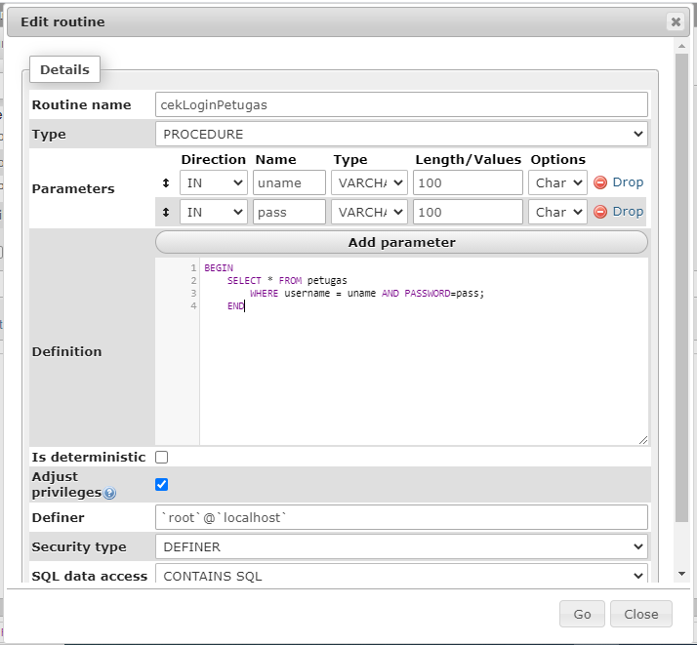

1. Procedure cekLoginSiswa

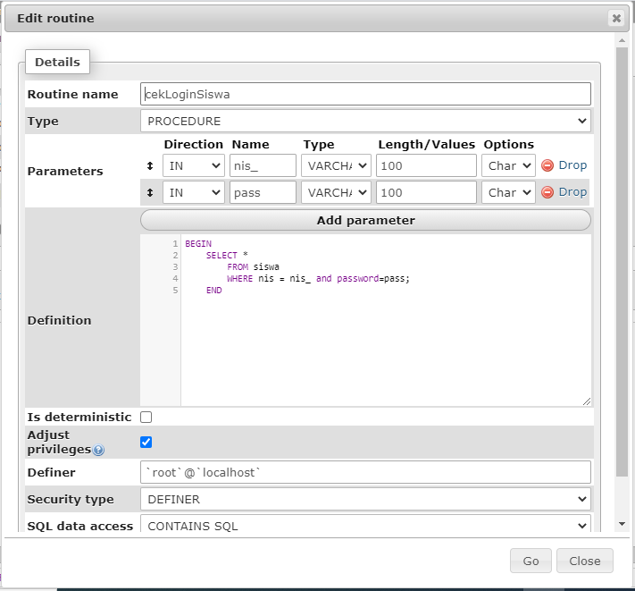

1. Procedure levelPetugas

